LBVT roadmap

user manual

Team: 2024-SP2-24

Name: Yuta Kasuga

The Kiet Ly (Sam)

Contents

1. Program outline 3

2. Web page 3

How to use the roadmap 4

Welcome building. 4

Course building 6

Elective building 8

Industry building 9

Alumni building 11

Camera 13

# Program outline

This document is for explaining how to use 3D web-design interactive program roadmap for Environmental Science (LBVT) for University of South Australia (Uni SA). Users can find course information, prerequisite for the course and the connection between futures’ one, elective information for the program, and the related YouTube videos in Uni SA’s official account.

# Web page

Users can check the program’s information with clicking it on the roadmap. When user click the building, new window will be popped up on and the information will be different from each type of building.

The roadmap has several types of buildings such as:

* Welcome: Displaying YouTube videos which related program.
* Course: Displaying course information.
* Elective: Display all type of electives’ course.
* Industry: Displaying partner companies of Uni SA.
* Alumni: Displaying alumni’s information

When user launch the application, it will be display as Figure1.

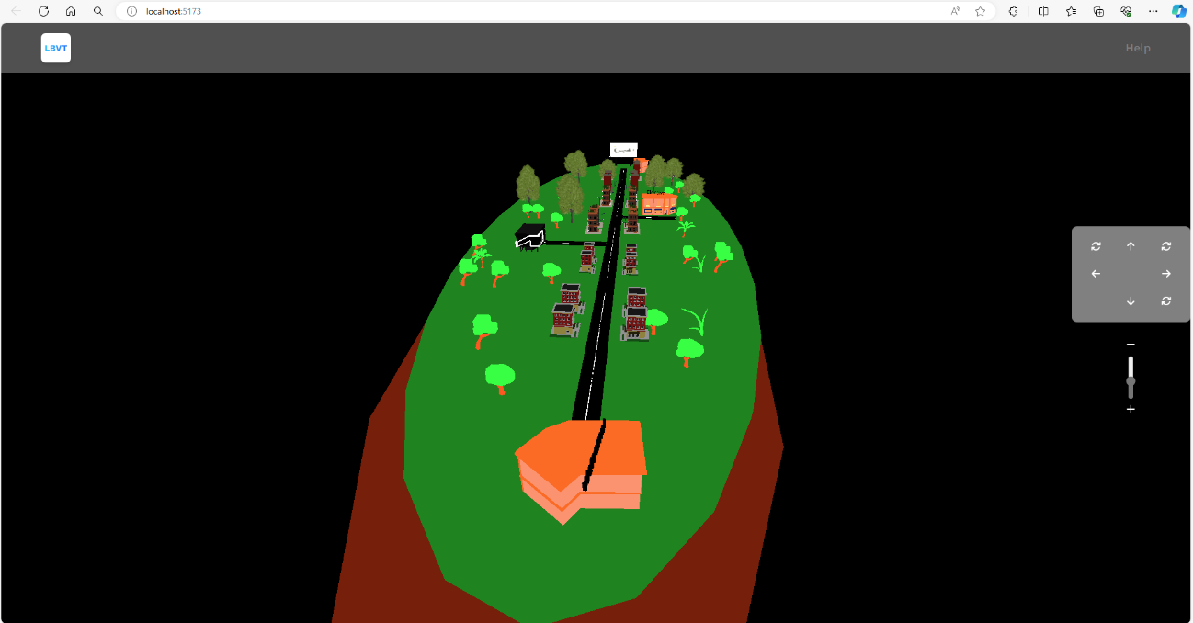

Figure1: Program Roadmap

## How to use the roadmap

* To launch the application. Enter “npm install” command in VS Code([Visual Studio Code - Code Editing. Redefined](https://code.visualstudio.com/))’s terminal to download necessary information. To launch the project, enter “npm run dev” command in the terminal the press “o” and enter key.
* To move your location, hold your right click down then move your mouse. or click arrow buttons which are right middle of the screen.
* To move your camera, hold your left click down then move your mouse. Or slide a +/- bar which are right middle of the screen to modifying the height.
* To reset camera, click the circle button which is on right bottom corner.
* To zoom in, scrolling up your mouse and scrolling down for zoom out.
* When you click the building, the related information will be popped up.
* To change the roadmap for different program, click the link in the Help page or enter “/program=lbvt” or “/?program=iboe” after the localhost::XXXX. (ex. localhost::5173/program=lbvt)

## Welcome building.

The welcome building (Figure 2) has responsibility for welcome message and displaying videos which related the program for perspective students(Figure 3). Therefore, they can understand what they will study during university life, campus information, and program director’s message. The videos are from Uni SA’s official YouTube channel.

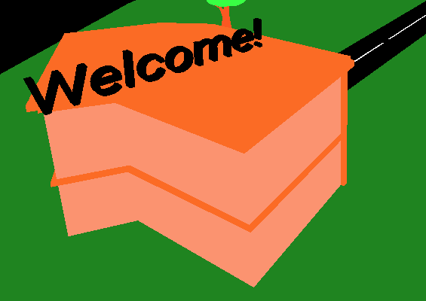

Figure2: welcome building on the roadmap

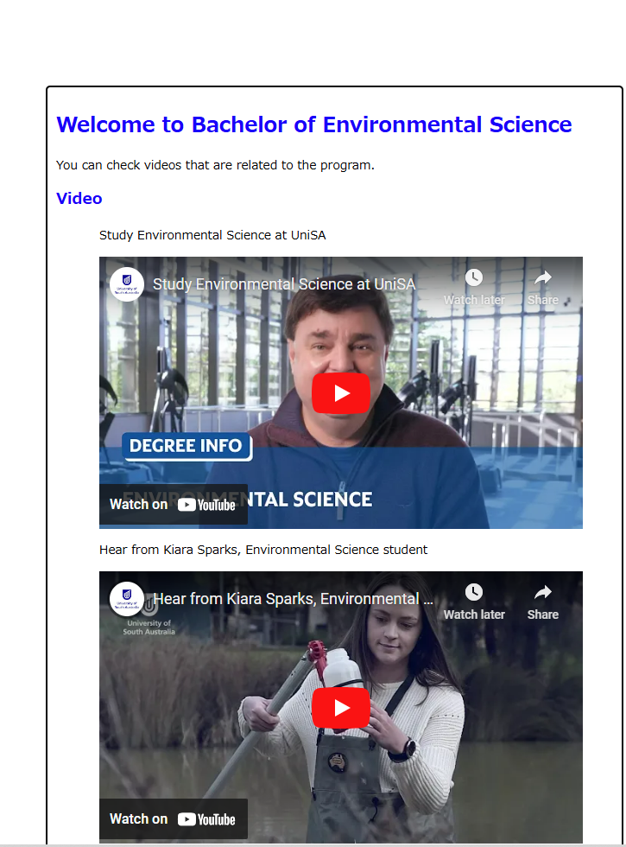

Figure3: window for welcome building

## Course building

For imaging journey, there are multiple buildings on the roadmap and each building has each course information of the program (Figure 3). There are 24 course buildings on the map and each building has one course information.

If the course has prerequisite for the future courses, the related building will be highlighted with green. In course UI (Figure 4), user can check course information such as course name with link to Uni SA course page, course id, course aim, and so on. User can check the related courses in the page as well.

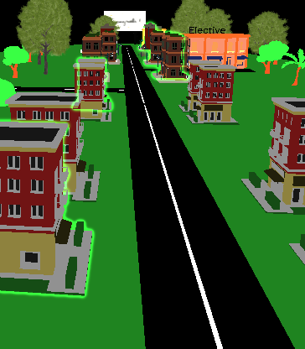

Figure3: course buildings with highlighted

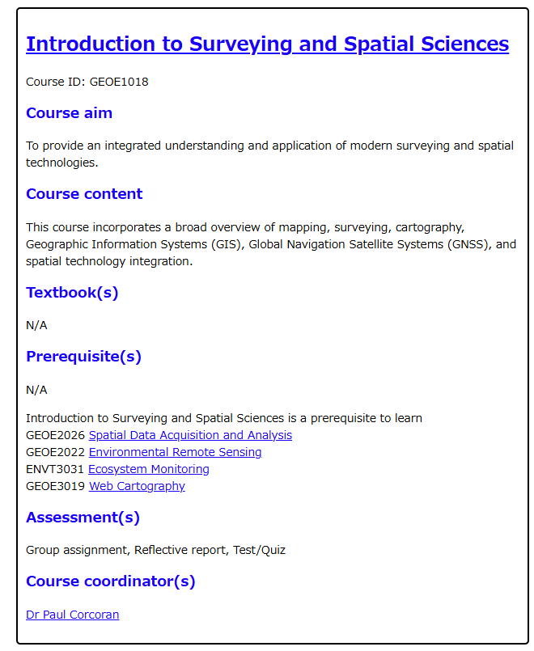

Figure4: Course UI for GEOE1018

## Elective building

The elective building (Figure 5) has responsibility for displaying elective information. When user click the building, new window(Figure 6) will be popped up with electives’ information. Every elective section’s information such as undergraduate elective, and environmental elective will be displayed.

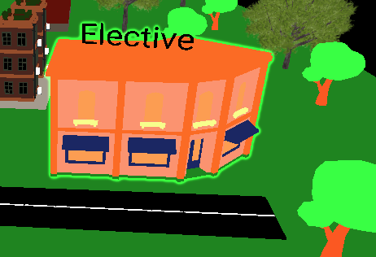

Figure5: elective building on the roadmap

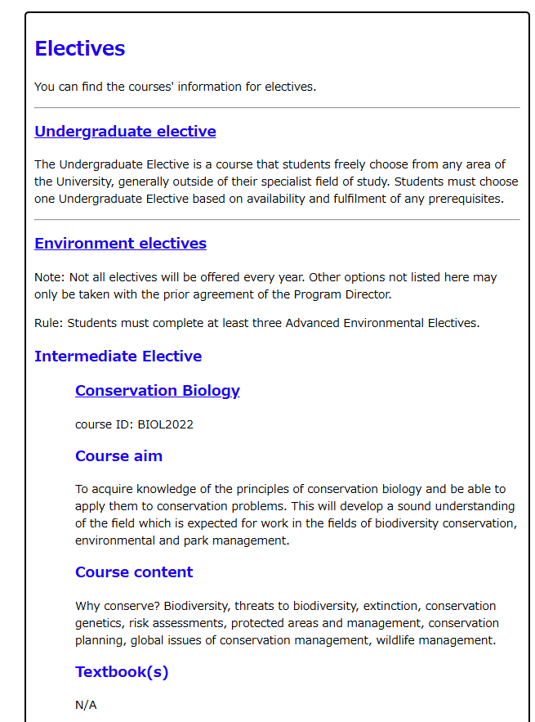

Figure6: Elective page for LBVT program

## Industry building

The industry building (Figure 7) has responsibility for displaying partner companies of Uni SA for the related industry (Figure 8).

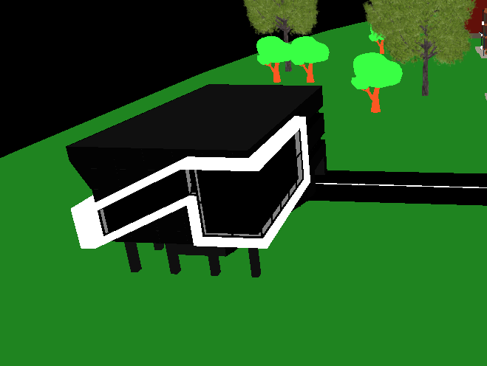

Figure7: industry building on the roadmap

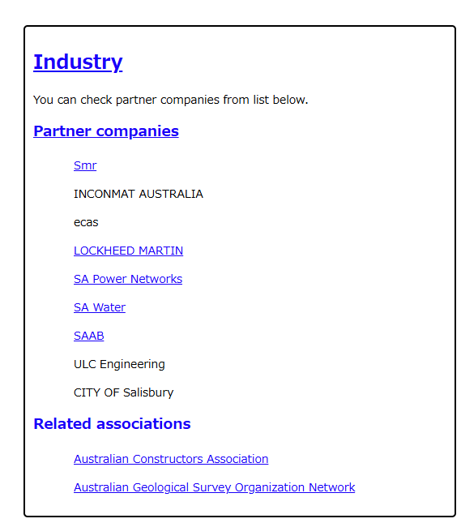

Figure8: industry page for LBVT program

## Alumni building

Alumni building (Figure 9) has responsibility for displaying the link to alumni’s information (Figure 10).

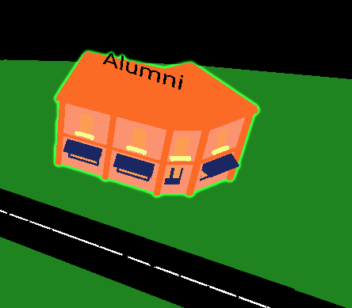

Figure9: Alumni building on the roadmap.

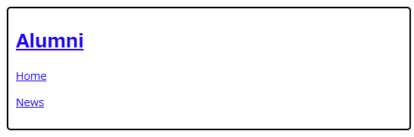

Figure10: Alumni page

## Camera

User can control cameras with buttons (Figure 11) as well. In case of preferring using mouse for controlling camera, please check How to use the roadmap section in page 4.

How to use buttons:

* Arrow buttons (→, ↓, ←,　↑):

Move the camera’s position slightly to the direction

* Rotate buttons on the top rows:

Change the camera’s direction 90 degree.

* Rotate button on the right bottom of the corner:

Reset the camera’s position to initial place.

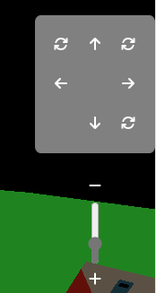

Figure11: buttons and slide bar for camera

## Help page

There is the Help page (Figure 12) which explain how to use the system. This page also has the link for changing the program information. User can change the program with the link in this page.

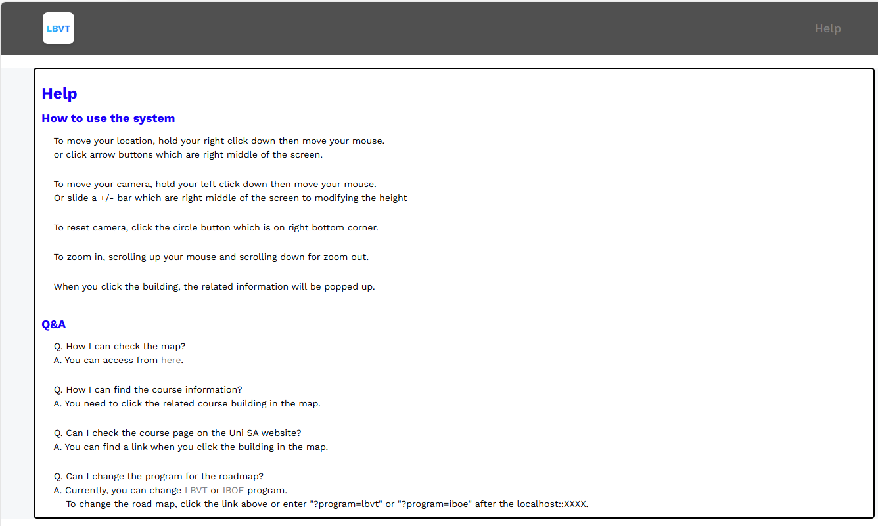

Figure12: Help page